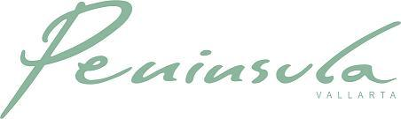

March 31, 2020
Dear Homeowners,

Receive a warm greeting, hoping you are well, along with this new message regarding COVID-19.

First of all we want to thank by this means the support and response of all of you to this contingency that, as you know, has already been declared a Sanitary Emergency by the Government of Mexico.

The main reason for this message is to reiterate that the Bylaws are being applied, in the matter of rentals, and no stay of a minimum of 60 days is being allowed to enter the condominium. Therefore, to avoid any kind of situations and even probable claims, we ask, once again, to those homeowners that rent to immediately cancel all future rental arrivals that are less than this time, since access will be denied upon arrival. This measure will remain in effect until further notice that states otherwise.

We also want to insist and reiterate that the common areas of the condominium are close, to avoid people gathering and other situations of possible contagion:

- lobby,
- lobby bar,
- movie theatre,
- game room,
- spa/massage room,
- meeting room,
- pool terrace and pool)

On the other hand, as you have also been informed previously, we are keeping in the condominium the minimum personnel necessary to keep functional and in minimum order the essential services of the condominium, such as water, electricity, elevators, garbage removal, shelter, security and access control.

The administration will be attending from home, from 9am to 5pm, and you can find us by mail, or by calling the Condominium, leaving a message with Security.

Now, in order to organize the Personnel issue in the best way, we ask:

- To all those residents, who take the garbage out of their units between 9:00 am and 11:00 am, at the latest, to facilitate the waste removal maneuver by the personnel involved in it.

- To all those condominium owners who plan to occupy their units by themselves in the near future, notify us in advance by sending an email to the administration.

We will continue to send communications, as situations arise, in the meantime, stay well.

Sincerely,

Ramón Jiménez
Gerente General // General Manager
ARPV II, A.C.

